WILLETTON SENIOR HIGH SCHOOL



Electricity Test - 2019

44

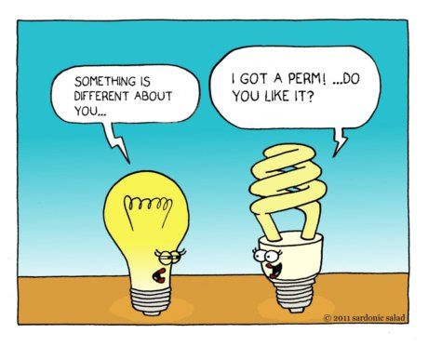

Student name: _Solutions_

Teacher (Please tick one box)

Mr Boughton □ Group 5

Mr Dopson □ Group 2

□ Group 3

Mrs Munshi □ Group 4

Dr Pitts □ Group 1

# TIME: 1 Hour

**NOTE:**

1. Calculation questions must be structured and show clear working with answers stated to **three significant figures.**

2. **Marks will be allocated for clear and logical setting out.**

Answer

3. Place your final answers in the box provided. Eg.

4.State assumptions if working on open ended type questions.

**Section One: Short answers (30 marks)**

**Q 1.**

1. Which of the following graphs best represents a non-ohmic conductor? (1 mark)

Answer:

I

I

I

I

C

V

V

V

V

[A] [B] [C] [D]

1. Why did you select this graph? (2 marks)

**1**



**1**

**Q 2.**

Explain why the metal copper is a better electrical conductor than rubber. (2 marks)

**Delocalised electrons in the conduction band**. So metals are good conductors as the electron in their **outer shell is loose** and can **plunge out of the atom** with the application of the slightest force(voltage).

**1**

**No free electron in the conduction band**

**1**

ALSO:

Copper is the preferred as it has high electrical conductive.

Rubber is not preferred as the properties of rubber will cause the electrons to slow down and eventually prevent them from moving at all. (Keeping electricity bound within the material is the main goal of an insulator – making rubber a very good choice, especially in the form of electrical mats)

**Q 3.**

When a resistor is connected to a 9 V battery, 1.57 × 1021 electrons pass through the resistor

in a time of 90 seconds.

If missing – 1 maximum

a) Calculate the current in the resistor. (2 marks)

**2.79 A**

**Number of electrons = 1.57 x 1021 t = 90 s**

**I = q/t = (1.57 x 1021x 1.6 x 10-19)/90 = 2.79 A**

**1**

**½**

**½**

b) Calculate the work done on the electrons by the battery. (2 marks)

**W = Vq = 9 x 1.57x1021 x 1.6x10-19**

**2.26x103 J**

**½**

**½**

**= 2.26x103 J**

**Also:**

**W = VIt**

**= 9x 2.79x90 (1 only if 1.5)**

**= 2.26x103 J**

**1**

**Q 4.**

A television marked 240 V, 150 W and is operated for five hours a day, seven days a week for 52 weeks.

a) How much energy (in kilowatt hours) will the TV consume in that time?

(3 marks)

**1**

**½**

**273 kWh**

**E = P*t = 150x10-3 x (5x7x52)**

**½**

**= 0.15 x 1820**

**1**

**273 kWh**

b) If a kilowatt-hour costs 16 cents, find the cost of the electricity consumed by the TV in one year?

(1 mark)

**Cost = E x rate = 273 x 0.16**

$43.68

**= $43.68**

**1**

**Questions** **5** **to** **8** uses the following circuit diagram showing the connections of three similar resistors (labelled 1, 2 and 3). With the switch **closed**, answer the questions.

C

E

F

G

A

B

D



2



1



3

**5**) The direction of conventional current flow is from: (1 mark)

Circle the correct answer: G to A B to A D to A

**6**) To determine the potential difference across resistor 2, you would use the points: (1 mark)

Circle the correct answer: A and C A and F B and C

**7**) There is no potential difference between the points: (1 mark)

Circle the correct answer: A, D and G A, B and C E, F and G

**8**) Comparing the amount of current going through points A, D and G, the order from the greatest amount of current to the least is: (1 mark)

Circle the correct answer: A, D then G G, A then D G, D then A

**Q 9.** A student completes an electric circuit that includes a mystery box as shown below.

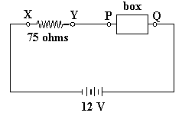

If the potential difference between X and Y is 9.0 volts, which of the following

boxes – A, B, C or D – would be the mystery box?

boxes (A - D) is in the circuit? (1 mar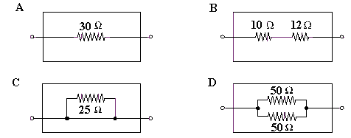k) followindiagram

**D**

**Equivalent R:**

**RA = 30 Ω**

**RB = 22 Ω**

**RC = 0 Ω**

**RD = 25 Ω**

**Is = 9/75 = 0.12 A**

**Vbox = 12 – 9 = 3 V**

**Therefore: Rbox = 3/0.12 = 25 Ω.**

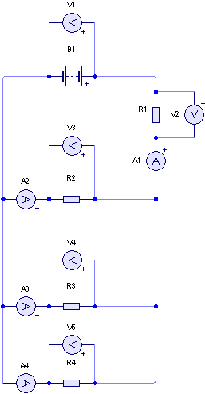**For questions 10-12 consider the following diagram**

**10)** Write a mathematical relationship between V1, V2, V3, V4 and V5? (1 mark)

**V1 = V2 + (V3 = V4 =V5)**

**11)** Write a mathematical relationship between A1, A2, A3 and A4. (1 mark)

**A1 = A2 + A3 + A4**

**12)** If R1, R2, R3 and R4, are all 30.0 Ω resistors, what is the total resistance of   
the circuit? (2 marks)



Minor error in solution

**1**

**1**

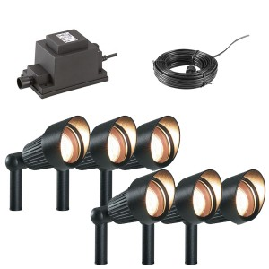**Q 13.**

A garden lighting system consists of 4 (four), 13 Ω lamps, connected in parallel. The system is driven by a 12 V solar panel. A safety feature of the circuit is a fuse, which is designed to cut the power if the current in the circuit exceeds 8.00 A.

Not happy with number of lamps, a home handyman wanted to connect extra lamps in parallel with the existing system.

**a)** Draw the electric circuit for the existing four lamp lighting system. (3 mark)

**1 – lamps**

**1 – parallel**

**1 – fuse**

**-1 – solar panel  
(must be identified)**

Solar panel

**Note: fuse must be on the + side if polarity used. Else either side.**

**b)** How many lamps can he have in the system without blowing the fuse? Show all  
calculations required. (4 marks)



**Also:**

**V = 12 v, I = 8 A.**

**Rt = 1.5Ω**

**1**

**1**

**1**

**1**

**8**

**Q 14.**

During a practical lesson a group of students constructed a circuit that contained a 40.0 Ω resistor, a 20.0 Ω resistor and a lamp (‘A’), in parallel with each other. This combination was then placed in series with a 50.0 Ω resistor, as shown below. The lamp had a resistance of 40.0 Ω and the circuit was connected to a power pack set on 12.0 V.  
For this question: assume that Lamp A was an ohmic resistor.



1. On the diagram above, use an arrow to indicate the direction of electron current in this circuit. (1 mark)
2. Calculate the total resistance of the circuit. (2 marks)

**1/Rp = 1/20 + 1/40 +1/40 = 4/40**

**60.0Ω**

**1**

**Rp = 10Ω**

**1**

**RT = 10 + 50 = 60 Ω**

**Check for sig fig, -½ only in b, & c.**

1. Calculate the total current in the circuit. (2 marks)

**½**

**½**

**IT = V/R =12/60**

**0.200 A**

**Or**

**200 mA**

**= 0.200 A**

**1**

(d) The students then used a voltmeter to measure the potential difference across  
the 50.0 Ω resistor.

1. On the diagram on page 8, draw how they would have connected the voltmeter to the circuit. (1 mark)

**As shown on the diagram.  
(It must be in parallel with the 50Ω resistor).**

1. Calculate the potential difference across the 50.0 Ω resistor. (2 marks)

**½**

**½**

**10.0V**

**V50 = IT x R50 = 0.2 x 50**

**V50 = 10 V.**

**Check for sig fig, -½ only in d (ii)**

**1**

(e) Determine the power dispersed in the 50.0 Ω resistor. (2 marks)

**½**

**½**

**2.00 W**

**P50 = V50 x IT = 10 x 0.2**

**or**

**P50 = (V50)2/50) =100/50**

**or**

**P50 = (IT2 x 50) =0.04 x 50**

**P50 = 2.00 W**

**1**

**Q15.**

**a)** Draw a circuit containing a power supply, a globe, a closed switch and a fuse. Include in your diagram a bare piece of wire which short circuits the globe, that is, stops the globe from glowing. (2 marks)

Globe

Short cct

**½ – power supply**

**½ – Globe**

**½ – closed switch**

**½ – fuse**

**- ½ – no short cct**

Fuse

Power supply

Closed switch

b) Use dot points to explain why the fuse may blow in this short circuit situation. (3 marks)

The globe circuit (without the fault) will have sufficient current to illuminate the globe.

The short circuit eliminates the resistance of the globe to nearly zero.  
(this reduce the resistance of the network – depending on other R values)

The short circuit provides a lower resistance for the current to flow.

A lower resistance results in a dramatic increase in the current in the circuit.

This fault current is likely to exceed the rating of the fuse.

Thishigh electrical energy is converted to heat energy (I2R*t) which melts the fuse wire

This melted or blown fuse create an open circuit and stops the excess current to flow.

**END OF TEST, PLEASE CHECK YOUR ANSWERS**